A204-Afr-Egy-Ushabti-Third Intermediate Period, 21st Dynasty, 1080-945 BCE

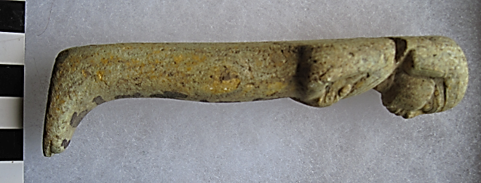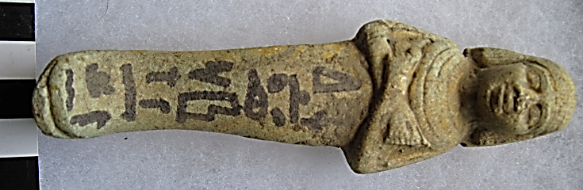

**Case No.: 2**

**Formal Label: Egyptian Ushabti** Third Intermediate Period, 21st Dynasty, ca 1080-945 BCE

**Display Description: Mummiform, body beige terracotta, round wig with fillet, hands crossed left over right, four tiered necklace.**

**Accession Number: A204**

**LC Classification:** DT62

**Date or Time Horizon:** Third Intermediate Period, 21st Dynasty, ca 1080-945 BC

**Geographical Area: Possibly from Thebes**

**Map, GPS Coordinates:**

**Cultural Affiliation:** Third Intermediate Period, 21st Dynasty, ca 1080-945 BCE

**Medium:** Terracotta, painted inscription

**Dimensions:   
Weight:**

**Provenance:**

**Condition:**

**Discussion:** Local affairs in Thebes were mostly controlled by the High Priests of Amun, in the Third Intermediate Period. In fact, Amun priests owned two-thirds of temple lands and 90 percent of shipping vessels and so they were intimately involved with trade (Clayton 1994: 174-175). Amun priests were as powerful as the Pharaoh, since the High Priest of Amun controlled Upper Egypt in opposition to the 21st and 22nd Dynasty Pharaohs who controlled the Delta. In addition, familial connections through intermarriage strengthened ties between them, and several daughters of the Tanite kings were installed as “God’s Wife of Amun” which involved this office in the selection of the succeeding Pharaoh at Thebes.

**References:**

Clayton, Peter. 1994. *Chronicle of the Pharaohs*. London: Thames & Hudson.